EX.NO:3 Design of a Mobile Keypad focusing on size, layout and devilling

Aim: To design Mobile Keypad focusing on size, layout and devilling

Procedure:

some guidelines to focus on when designing a mobile keypad:

1.Size:

* Ensure that the keys are large enough to be easily tapped by users, especially on smaller screens.
* Consider the average size of a user's fingertip and allow for enough spacing between keys to minimize accidental touches.

2.Layout:

* Organize the keys in a logical and intuitive manner, such as following the QWERTY layout commonly used in mobile devices.
* Group related keys together, such as numbers, letters, symbols, and special characters, to improve usability and efficiency.
* Prioritize frequently used keys by placing them in prominent or easily accessible positions.

3.Dividing the Keypad:

* Separate the keypad into functional sections, such as a number pad, letters, and symbols, using clear visual cues or dividers.
* Implement tabs or swipe gestures to switch between different sections of the keypad, if necessary, to reduce clutter and improve usability.

4.Visual Design:

* Use clear and legible fonts for the labels on the keys to enhance readability.
* Ensure sufficient contrast between the key labels and the background color to improve visibility.
* Consider providing visual feedback, such as highlighting the pressed key or displaying characters as they are entered.

5.Predictive Input and Auto-correction:

* Implement predictive input mechanisms, such as auto-suggestions or word completion, to speed up text input and reduce errors.
* Incorporate auto-correction algorithms to automatically correct common typing mistakes, improving the accuracy of text entry.

6.User Testing and Feedback:

* Conduct user testing to evaluate the usability of the keypad design. Gather feedback from users to identify areas of improvement and address any usability issues.
* Iteratively refine the design based on user insights and feedback to ensure an intuitive and user-friendly experience.

Coding:

<!DOCTYPE html>

<html>

<head>

<title>Mobile Keypad Design</title>

<style>

/\* Basic styling for the mobile keypad \*/

.keypad {

display: grid;

grid-template-columns: repeat(3, 1fr);

gap: 5px;

}

.key {

padding: 15px;

font-size: 18px;

text-align: center;

background-color: #f2f2f2;

border-radius: 5px;

}

</style>

</head>

<body>

<h1>Mobile Keypad Design</h1>

<div class="keypad">

<div class="key">1</div>

<div class="key">2</div>

<div class="key">3</div>

<div class="key">4</div>

<div class="key">5</div>

<div class="key">6</div>

<div class="key">7</div>

<div class="key">8</div>

<div class="key">9</div>

<div class="key">\*</div>

<div class="key">0</div>

<div class="key">#</div>

</div>

</body>

</html>

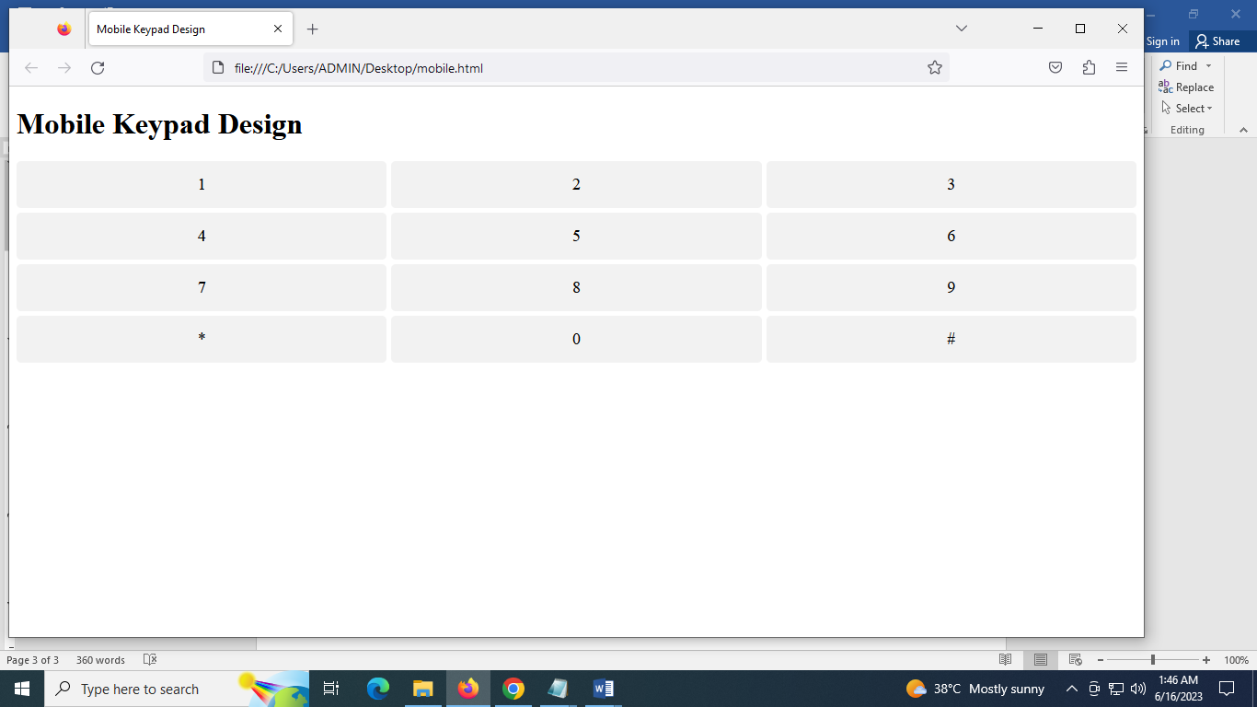

RESULT:

Thus the Mobile Keypad focusing on size, layout and devilling was designed.